**Adult Longitudinal Data Collection Guide**

|  |  |
| --- | --- |
| PROTOCOL | PAGE NUMBER |
| Assessments by Visit | 2-3 |
| Assessment Dictionary | 4 |
| Order of Procedures | 5-7 |
| Color Vision Test | 8 |
| Family History Questionnaires | 9 |
| Hollingshead SES | 10 |
| ACDS | 11 |
| 6 minute bike | 12 |
| Demos | 13 |
| Height, Weight, Vitals | 14 |
| Medications | 15 |
| Medical Conditions | 15 |
| Grip Strength | 16 |
| Blood Draw/Genetics | 17 |
| Urine Toxicology | 18 |
| Pregnancy Test | 19 |
| MRI | 20-22 |
| MRI Questionnaire | 22 |
| Calculated Age | 23 |
| MRN | 24-25 |
| Penn CNP | 26 |
| ANT | 27 |
| RVIP | 28 |
| SCID | 29 |
| Neuropsych Battery | 30 |
| Protocol Deviations | 31 |
| MoCA | 32 |
| Walking While Talking (WWT) | 33 |
| Vo2 Submax Testing | 34-35 |

|  |  |  |
| --- | --- | --- |
| Assessments by Visit  Visit type and visit code in LORIS database | Baseline Visit  (BAS1, BAS2, BAS3) | Follow-Up Visits  (FLU1, FLU2, FLU3) |
| Consent |  |  |
| Demographic Questionnaire |  |  |
| Weight/Height, Vital Signs, Hip/Waist Measurement |  |  |
| Blood Draw |  |  |
| Medications/Medical Conditions |  |  |
| Urine Drug Test (11+) |  |  |
| Penn CNP~ |  |  |
| SCID~ |  |  |
| 6-Minute Bike Test |  |  |
| MRI |  |  |
| MRI-Questionnaire |  |  |
| ANT~ |  |  |
| DKEFS~ – Verbal Fluency |  |  |
| DKEFS~ – Trails |  |  |
| DKEFS~ – Design Fluency |  |  |
| DKEFS~ – Color-Word |  |  |
| DKEFS~ – Tower |  |  |
| RAVLT~ |  |  |
| Grooved Pegboard |  |  |
| Digit Span |  |  |
| Family History Questionnaire |  |  |
| Hollingshead SES |  |  |
| ACDS |  |  |
| WASI~ |  |  |
| WIAT~ |  |  |
| Actigraphy*** |  |  |
| Color Vision |  |  |
| Grip Strength |  |  |
| RVIP~ |  |  |
| MoCA~ |  |  |
| Walking While Talking |  |  |
| VO2 Submax Testing |  |  |
| STAI~ |  |  |
| BDI~ |  |  |
| GDS~ (65+) |  |  |
| ASR / OASR~ (60+) |  |  |
| ASR-AF / OASR-AF~ (60+) |  |  |
| UCLA-PTSD Youth~ |  |  |
| TSC-40~ |  |  |
| ATQ~ |  |  |
| BISQ~ |  |  |
| CAARS~ |  |  |
| Demographics Supplement |  |  |
| EDEQ~ |  |  |
| FTND~ |  |  |
| IPAQ~ |  |  |
| IRI~ |  |  |
| Medical History Questionnaire |  |  |
| NIDA~ |  |  |
| NEO~ |  |  |
| PhenX Sexual History |  |  |
| PASE~ |  |  |
| PSQI~ |  |  |
| RRS~ |  |  |
| Satisfaction Questionnaire |  |  |
| Social Networking Questionnaire |  |  |
| PDI-21~ |  |  |
| CHRLS~ |  |  |
| CFQ~ |  |  |
| CASI-A~ |  |  |
| DOSPERT~ |  |  |
| TFEQ~ |  |  |
| Zip Code |  |  |
| ICUY~ |  |  |
| Sex Role Identity Scale |  |  |
| Sexual Orientation Scale |  |  |
| UPPS~ |  |  |
| EHQ~ |  |  |
| PTQ~ |  |  |
| ERQ~ |  |  |
| PSWQ~ |  |  |
|  |  |  |

~ Acronym is defined below in the Assessment Dictionary

***Actigraphy not collected for all participants due to availability of equipment and participant willingness.

|  |  |
| --- | --- |
| **Assessment Dictionary** | |
| ANT | Attention Network Test |
| ASR | Adult Self-Report |
| ATQ | Adult Temperament Questionnaire |
| BDI | Beck Depression Inventory - II |
| BISQ | Brain Injury Screening Questionnaire |
| CASI | The Comprehensive Addiction Severity Index for Adolescents |
| CAARS | Conners Adult ADHD Rating Scale – Self Report, Short Version |
| CFQ | The Cognitive Failures Questionnaire |
| CHRLS | The Cambridge-Hopkins Restless Legs Syndrome |
| DKEFS | Delis-Kaplan Executive Functioning System |
| DOSPERT | The Domain-Specific Risk-Taking Scale |
| EDEQ | Eating Disorder Examination Questionnaire |
| EHQ | Edinburgh Handedness Questionnaire |
| ERQ | Emotional Regulation Questionnaire |
| FTND | Fagerstrom Test for Nicotine Dependence |
| ICUY | Inventory of Callous Unemotional Traits - Youth |
| IPAQ | International Physical Activity Questionnaire |
| IRI | Interpersonal Reactivity Index |
| NEO | NEO Five Factor Inventory - 3 |
| NIDA | National Institute on Drug Abuse Questionnaire |
| PASE | Physical Activity for the Elderly |
| PDI | The 21-Item Peters et al. Delusions Inventory |
| PENN CNP | Penn’s Computerized Neurocognitive Battery |
| PSQI | Pittsburgh Sleep Quality Index |
| PSWQ | Penn State Worry Questionnaire |
| PTQ | Perseverative Thinking Questionnaire |
| RAVLT | Rey Auditory Verbal Learning Test |
| RRS | Ruminative Response Scale |
| RVIP | Rapid Visual Information Processing task |
| SCID | Structured Clinical Interview for DSM-IV – TR Axis I Disorders |
| SES | Hollingshead Four-Factor Index of Socioeconomic Status |
| STAI | State Trait Anxiety Inventory |
| TFEQ (12+) | Three-Factor Eating Questionnaire |
| TSC-40 | Trauma Symptoms Checklist for Adults |
| UCLA PTSD Youth | University of California at Los Angeles Posttraumatic Stress Disorder Reaction Index Youth |
| UPPS | Impulsive Behavior Scale |
| WASI | Weschler Abbreviated Scale of Intelligence Second Edition |
| WIAT | Weschler Individual Achievement Test – Second Edition Abbreviated |

Order of Administration: ALG Baseline Visit (2-day Protocol)

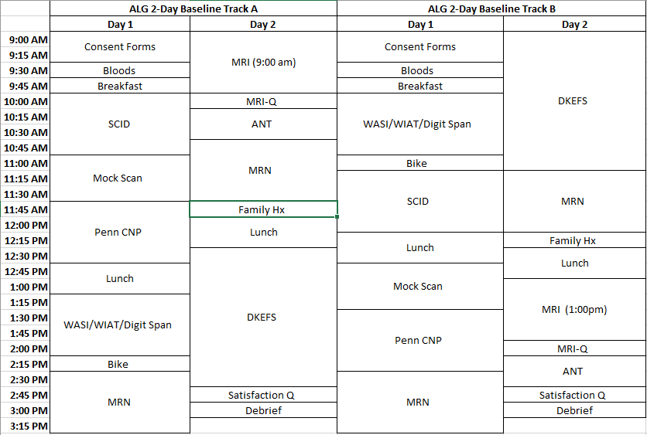

* **Consent Forms:** Consent, Demographics questionnaire, MRI screener, Contact Information
* **Bloods:** Weight/Height, Vital Signs, Hip/Waist Measurement, Medications/Medical Conditions, Grip Strength, Urine Drug Test, Blood Draw
* **MRN:** STAI, BDI-II, GDS (65+), ASR (38-59), OASR (60-85), ASR-AF (38-59), OASR-AF (60-85), TSC-40, UCLA-PTSD

Order of Administration: ALG Baseline Visit (1-day Protocol)

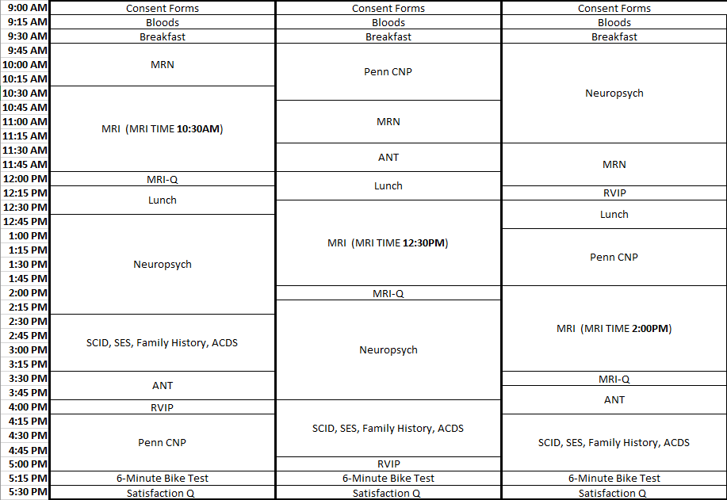

* **Consent Forms:** Consent, Demographics questionnaire, MRI screener, Contact Information
* **Bloods:** Weight/Height, Vital Signs, Hip/Waist Measurement, Medications/Medical Conditions, Grip Strength, Urine Drug Test, Blood Draw
* **MRN:** STAI, BDI-II, GDS (65+), ASR (38-59), OASR (60-85), ASR-AF (38-59), OASR-AF (60-85), TSC-40

Order of Administration: ALG Follow-Up Visits

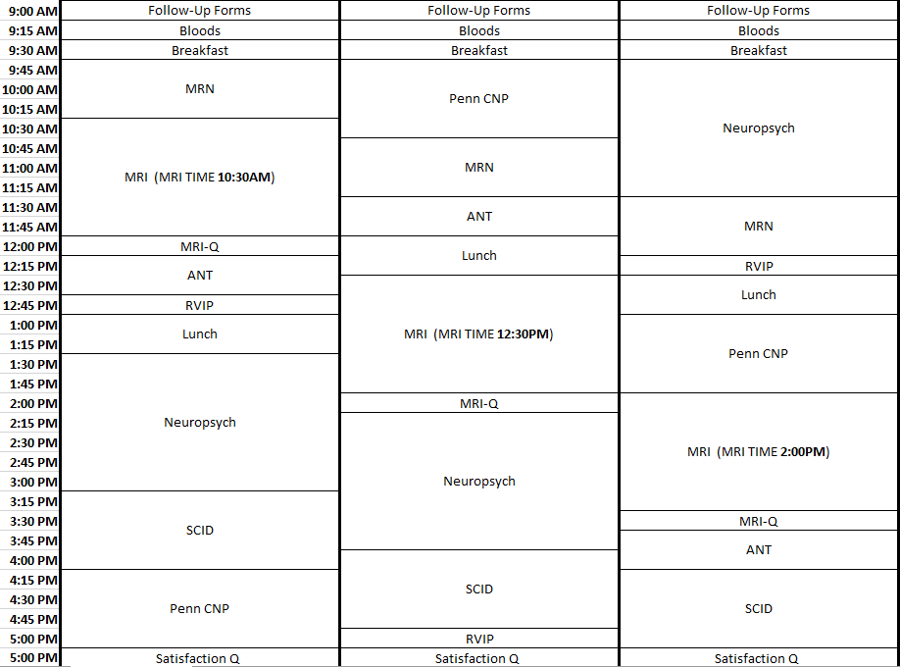

ALG Follow-Up Visit Protocol Labels Defined:

* **Follow-Up Forms:** Demographics questionnaire, MRI screener
* **Bloods:** Weight/Height, Vital Signs, Hip/Waist Measurement, Medications/Medical Conditions, Grip Strength, Urine Drug Test, Blood Draw
* **MRN:** STAI, BDI-II, GDS (65+), ASR (38-59), OASR (60-85), ASR-AF (38-59), OASR-AF (60-85), TSC-40
* **Neuropsych:** DKEFS Verbal Fluency, RAVLT (Immediate Recall), DKEFS Trails, Digit Span (Forward & Backward) , DKEFS Design Fluency, DKEFS Color-Word Interference, DKEFS Tower, Grooved Pegboard, RAVLT (Delayed Recall), WASI

**Color Vision Test**

**Assessment Used**: Ishihara’s Tests for Colour Deficiency (24 Plates Edition) 2007

Reference: Ishihara, S. The Series of Plates Designed as a Test for Colour-Deficiency. Tokyo, Japan: Kanehara Trading Inc. (1936).

**Test Administration:** The color deficiency test was administered in the NKI-RS outpatient research department medical examination room to ensure the room is lit adequately by daylight. The Ishihara’s Tests for Color Deficiency stimulus book plates were held 75cm from the subject and tiled so that the plate of the paper is at a right angle to the line of vision. The participant was asked to state (out loud) the number which is printed on the back of the plate. Responses were recorded indicating whether the subject could read the numeral(s).

**Family History Questionnaires**

**Assessment Used:** Family History Questionnaire, custom created by NKI-RS investigators

**Test Administration:** The family history questionnaires were completed in a private testing room and a white noise machine was turned on outside of the testing room to ensure participant confidentiality. Participant was asked to identify their living or deceased biological family members (i.e., Mom, Dad, Siblings, Children). Participant then recorded family history questionnaires on paper assessments for each family member and returned completed questionnaires to research assistant when completed. These data are not available through the Data Usage Agreement due to privacy concerns.

**Hollingshead SES**

**Assessment Used:** Hollingshead Four-Factor Index of Socioeconomic Status (SES)

Reference: Hollingshead, A. A. (1975). Four-factor index of social status. Unpublished manuscript, Yale University, New Haven, CT.

**Test Administration:** The Hollingshead SES was completed in a private testing room and a white noise machine was turned on outside of the testing room to ensure participant confidentiality. Participants were asked their highest level of education, highest grade completed, and highest level of occupation for themselves, their spouse , their mother, and their father (if known/applicable). Answers were recorded by the research assistant onto a paper version of the Hollingshead SES and were scored thereafter.

**ACDS**

**Assessment Used:** Adult ADHD Clinical Diagnostic Scale (ACDS)

Reference: Kessler, R. C., Green, J. G., Adler, L. A., Barkley, R. A., Chatterji, S., Faraone, S. V., . . . Van Brunt, D. L. (2010). Structure and diagnosis of adult attention-deficit/hyperactivity disorder: Analysis of expanded symptom criteria from the adult ADHD clinical diagnostic scale. Archives of General Psychiatry, 67(11), 1168-78.

**Test Administration:** The ACDS was completed in a private testing room and a white noise machine was turned on outside of the testing room to ensure participant confidentiality. The participant was asked to focus on the “period of time before they became a teenager, roughly the time corresponding to elementary or primary school.” The research assistant was then asked questions A1 – A21 aloud and responses were recorded on paper according to the ACDS scoring guidelines. The participant was then asked to “think about only the past twelve months, that is, since [month, year].” The research assistant was then asked questions B1 – B21 aloud and responses were recorded on paper according to the ACDS scoring guidelines.

**6 minute bike**

**Bike Used:** Precor (RBK 10: HCOM 815)

**Test administration:**

1. A resistance level and estimated wattage at 70 RPM were determined based on participants’ age and gender.

|  |  |  |  |
| --- | --- | --- | --- |
|  | **Age** | **Resistance** | **Estimated Wattage at 70 RPM** |
| **Males** | **< 35** | **8** | **133.16** |
| **35-55** | **7** | **121.89** |
| **>55** | **6** | **110.62** |
| **Females** | **<35** | **7** | **121.89** |
| **35-55** | **6** | **110.62** |
| **>55** | **5** | **99.35** |

1. A pulse oximeter was applied to the participant’s finger to monitor heart rate throughout testing. Participants were also instructed to grip the heart rate monitor on the bike’s handles throughout testing as a secondary way of measuring their pulse rate.
2. Participant’s initial heart rate was recorded from the bike and pulse oximeter.
3. Participants were instructed to begin pedaling at 70 rpm and the appropriate resistance level was set.
4. Participants were asked to cycle for 6 minutes, during which they were monitored to ensure that their speed was between 68-72 rpms. If the participant was unable to complete the full 6-minute interval, failure time was recorded.
5. Final heart rate was recorded from the bike and pulse oximeter at the end of the 6-minute interval, or at time of failure.

**Demos**

**Assessments Used:** Demographics Form

**Administration:** Participants were given the demographics form and asked to fill in their age, date of birth, sex, ethnicity, race, and native language at each annual visit. If the information given changed year to year, this was clarified with the participant and responses were adjusted as needed to ensure accuracy. Native language was defined as the primary language learned and spoken during childhood.

**Height, Weight, and Vital Signs**

**Administration:** The participant’s height, weight, and vital signs were taken in a medical exam room in the outpatient research department. The participant stepped onto a weighted scale and weight was recorded in pounds (and converted into kilograms thereafter). Blood pressure was taken using a digital sphygmomanometer (American Diagnostic Corporation e-sphyg) with a research assistant listening with a stethoscope simultaneously to ensure accuracy. A radial pulse was also recorded by the digital sphygmomanometer. Waist and hip measurements were also recorded in centimeters during this time.

**Medications & Medical Conditions**

**Administration:** All medications and supplements taken on a regular basis were recorded in a private testing room. All medications and supplements were recorded in their generic forms. A white noise machine was turned on outside of the testing room to ensure participant confidentiality. Participants were advised to compile a list of their medications and the dosages prior to coming in for their appointments in order to enhance accuracy of the self-report. Participants were also asked to self-report any illnesses or health conditions. This was cross-referenced with the primary indications on the medications form to ensure accuracy of the self-report.

**Grip Strength**

**Instrument used:** Sammons Preston Jamar Plus+ Digital Hand Dynamometer

**Administration:** Participants were asked to squeeze the dynamometer as hard as possible, three times on each hand, switching back and forth between their left and right hands. All measurements were averaged for each hand, and participants reported which hand was dominant.

**Blood Collection & Genetics Sample Collection**

**Collection:** Seven vials of blood were collected in the same order at each visit to perform the following analyses:

|  |  |  |
| --- | --- | --- |
| **Vial** | **Panel(s)** | **Tests** |
| Vacuette 4 ml K3E K3eDTA tube | CBC, ESR, Ferritin | CBC (Dif + Platelets)  Sedimentation Rate  Ferritin |
| Vacuette 8mL Z Serum Sep Clot Activator | SMAC | Albumin                           Glucose                     Total Bili  Alk Phos                           LDH                        Total Protein BUN                                  Phosphorus            Uric Acid   Triglycerides Potassium  Globulin  Cholesterol                      SGOT (AST)                GFR  Chloride                           A/G Ratio Sodium  CO2                                   SGPT (ALT)                  Creatine |
| Lipid Profiles | Cholesterol LDL  CHO/HDL Ratio HDL  Triglycerides |
| Vacuette 8mL Z Serum Sep Clot Activator | Thyroid Panel 1 | TSH, Free T4 |
| Vacuette 8mL Z Serum Sep Clot Activator | CRP | C-Reactive Protein Test |
| Vacuette 4 ml K3E K3eDTA tube | HbA1C | Hemoglobin A1C |
| BD Vacutainer 8.5 ml ACD Solution A tubes | Metabolites | Tryptophan Leucine  Quinolinic acid Phenylalanine  Tyrosine Valine  Isoleucine Kynurenine |
| BD Vacutainer 8.5 ml ACD Solution A tubes | Metabolites | Tryptophan Leucine  Quinolinic acid Phenylalanine  Tyrosine Valine  Isoleucine Kynurenine |

After the blood collection, the two metabolite tubes were spun down in a centrifuge at 4000 rpm for 10 minutes at room temperature. Plasma was transferred to cryogenic tubes and stored in a -70°C freezer. All other tubes were brought to the OMH Clinical Laboratory at NKI for processing. Samples collected over the weekend were either spun down (8 mL tubes) or refrigerated (4 mL tubes) and brought to the lab immediately upon its reopening the following Monday.

Three additional vials containing genetics samples were collected at one visit (typically Visit A). Immediately after collection, the genetics samples were packaged and sent to the RUCDR- Nelson Labs to be processed and made available through the NIMH Genetics Repository.

**Urine Toxicology**

**Test used:** CLIAwaived, Inc Rapid Drug Test Cup (CLIA-14-RDTC)

**Administration:** Urine was typically collected at the beginning of the day and tested for the presence of amphetamine, barbiturates, benzodiazepines, buprenorphine, cocaine, ecstasy, methadone, methamphetamine, marijuana, opiates, oxycodone, phencyclidine, propoxyphene, tricyclic antidepressants. Test lids were read approximately 5 minutes after activation.

**Urine Pregnancy Test**

**Test used:** Sure-Vue Urine hCG Strips (Fischer HealthCare)

**Administration:** All female participants under the age of 60 were offered a pregnancy test prior to their MRI scan.

The test strips were then read after 3-4 minutes and a positive or negative result was determined and recorded. A positive test was a contraindication for the MRI.

**MRI & MRI Questionnaire**

**Instruments:** 3T Siemen’s MRI scanner, Linux computer, Lumina Box, AcqKnowledge 4.2 BIOPAC program, “Memory of Trees” CD by Enya, Biopac Systems Disposable RT electrodes, Biopac Systems Respiratory Efforts Transducer, Brain Logics MR Digital Projection System, 32 Channel head coil, noise-cancelling headphones, disposable earplugs

**Task Administration:**

Prior to scanning, participants were screened for contraindications including specific medical conditions and metal artifacts in or on their person to ensure safety. After the participants were cleared for the MRI, the research assistant provided instructions for each scan (included in the list below) upon walking participants to the scanner. Participants’ were asked to remove everything from their pockets as well as bags, jewelry, belts, hearing aids, dentures, hair clips, or piercings. Participants’ belongings were stored and locked in a secure room. If applicable, the time of participants’ caffeine intake prior to scanning was recorded.

To prepare participants for scanning, the research assistants provided practice instructions and related stimuli for each scan on a Linux computer. The participants were then taken into the scanning room by the MRI technician(s) and were fitted with a respiration belt around their waist, a pulse transducer, and electrodes on their fingers to record their respiration rate, pulse rate, and galvanic skin response (GSR), respectively. Additionally, participants were provided with ear plugs and headphones to reduce noise in the scanner. Participants were given an emergency button to alert the research assistant and technician(s) if they felt that they could no longer continue scanning. For specific scans, participants were also given a pad with four buttons to press in response to applicable stimuli.

Upon entering the MRI tunnel, the research assistant ensured that the participants were prepared for scanning via microphone, and checked that the microphone was at an appropriate volume for the participants. On the computer, the research assistant completed a calibration period in which they reviewed the respiration, pulse, and GSR waveforms through the AcqKnowledge 4.2 computer program to verify that the signals were clear. Throughout scanning, the research assistant provided the specific length and instructions to the participants for each upcoming scan by reading an established script verbatim. BIOPAC data were saved for each applicable scan by the research assistant from the AcqKnowledge program. Participants were reminded to remain as still as possible throughout scanning and were able to speak to the research assistant via microphone in between each scan.

The following table includes the names, lengths, and instructions for each scan that participants completed. During scans with music, a “Memory of Trees” CD by Enya was played.

|  |  |  |  |  |
| --- | --- | --- | --- | --- |
| **Name of Scan** | **BIOPAC Data** | **Music** | **Stimuli** | **Instructions** |
| BIOPAC Calibration | Waveforms reviewed, data not saved | Off | None | Participants were asked to inhale, hold their breath for 1-2 seconds, and exhale for a short period of time. MRI technicians adjusted participants’ sensors as necessary. |
| Localizer (1 minute) | Off | On | None | Participants were informed that the scan would be 1 minute long and would include music. Participants were instructed to keep their eyes open or closed, whichever was more comfortable. |
| REST_645 | On | Off | Fixation | Participants were informed that the scan would be 10 minutes long and that they should keep their eyes fixated on the cross. |
| MPRAGE | Off | On | Fixation | Participants were informed that the scan would be 4 minutes long and would include music. They were told that they could keep their eyes open or closed. |
| REST_1400 | On | Off | Fixation | Participants were informed that the scan would be 10 minutes long and that they should keep their eyes fixated on the cross. |
| REST_CAP | On | Off | Fixation | Participants were informed that the scan would be 5 minutes long and that they should keep their eyes fixated on the cross. |
| CHECKER_645 | On | Off | Checkerboard | Participants were told to keep their eyes focused on a red dot on the screen and to press any button each time they saw the checkerboard appear behind the dot. They were informed that the scan was 2 minutes long. |
| CHECKER_1400 | On | Off | Checkerboard | Participants were told to once again keep their eyes focused on a red dot on the screen and to press any button each time they saw the checkerboard appear behind the dot. They were informed that the scan was 2 minutes long. |
| BREATH_HOLD_1400 | On | Off | Breath Hold | Participants were instructed to follow the prompts on the screen for the duration of the 4 minute scan. They were reminded that they should breathe normally whenever they saw the word “rest” and that they should keep as still as possible when taking deep breaths. They were advised not to worry if they could not hold their breathe for the full interval indicated by the prompts, but to try their best. |
| PCASL_REST | On | Off | Fixation | Participants were informed that the scan would be 5 minutes long and that they should keep their eyes fixated on the cross. |
| DIFF_137 | On | On | Fixation | Participants were informed that the scan would be 6 minutes long and include music. They were told that they would feel the table shake and vibrate, but that this was normal. They were also told to keep their eyes open or closed, whichever they preferred. |
| HCP_SPACE & FLAIR | Off | On | Fixation | Participants were informed that the final scan would be seven minutes long. They were reminded that they could keep their eyes open or closed. |

Immediately after the scan, participants completed the **MRI-Questionnaire (MRI-Q)**, a short survey detailing their experiences and thoughts during the MRI scan.

**Calculated Age**

**Administration:** Participant’s exact age at the time of the MRI scan was calculated based on the date of the appointment and their date of birth. All calculations were made using 12-month years and 30-day months.

**MRN: A set of self assessment questionnaires completed through the Mind Research Network (MRN) online interface.**

**Administration:** Participants were seated at a computer and given the following instruction:

“*You’re going to be answering a lot of questionnaires about several different topics. You’ll notice the questionnaires are a bit repetitive, they are supposed to be that way to maintain validity for all responses. If you have any questions, feel free to ask.*”

Participants then completed the following surveys **on-site:**

State Trait Anxiety Inventory (STAI)

Beck Depression Inventory – II (BDI)

Geriatric Depression Scale (GDS)

Adult Self-Report / Older Adult Self-Report Adaptive Functioning (ASR/OASR Adaptive Fx)

Trauma Symptoms Checklist for Adults (TSC-40)

University of California at Los Angeles Posttraumatic Stress Disorder Reaction Index (UCLA-PTSD)(*Child measure used across all ages in NKI-RS studies)

**Prior to coming in for visits,** participants completed the following surveys at home:

Adult Temperament Questionnaire (ATQ)

Brain Injury Screening Questionnaire (BISQ)

Conners Adult ADHD Rating Scale – Self Report, Short Version (CAARS)

Demographics Supplement

Eating Disorder Examination Questionnaire (EDEQ)

Fagerstrom Test for Nicotine Dependence (FTND)

International Physical Activity Questionnaire (IPAQ)

Interpersonal Reactivity Index (IRI)

Medical History Questionnaire– Adult

National Institute on Drug Abuse Questionnaire (NIDA)

NEO Five Factor Inventory – 3 (NEO)

PhenX Sexual History

Physical Activity Scale for the Elderly (PASE)

Pittsburgh Sleep Quality Index (PSQI)

Ruminative Response Scale (RRS)

Satisfaction Questionnaire

Social Networking Questionnaire

The 21-Item Peters et al. Delusions Inventory (PDI-21)

The Cambridge-Hopkins Restless Legs Syndrome Version 2 (CHRLS)

The Cognitive Failures Questionnaire (CFQ)

The Comprehensive Addiction Severity Index for Adolescents (CASI-A)

The Domain-Specific Risk-Taking Scale (DOSPERT)

Three-Factor Eating Questionnaire (TFEQ)

Zip Code

Inventory of Callous-Unemotional Traits*

|  |
| --- |
| Sex Role Identity Scale* |
| Sexual Orientation Scale*  UPPS-P Impulsive Behavior Scale (UPPS)*  Edinburgh Handedness Questionnaire (EHQ)*  Perseverative Thinking Questionnaire (PTQ)**  Emotional Regulation Questionnaire (ERQ)**  Penn State Worry Questionnaire (PSWQ)**  *Completed at baseline visits only  **Completed at follow-up visits only  **A description of each assessment listed above can be found here:** <http://fcon_1000.projects.nitrc.org/indi/enhanced/assessments/master_list.html> |

All responses were reviewed by research staff to check for completion.

**PENN CNP**

**Assessment Used:** University of Pennsylvania Computerized Neuropsychological Testing

References: Gur, R.C., et al. (2009). A cognitive neuroscience-based computerized battery for efficient measurement of individual differences: Standardization and initial construct validation. Journal of Neuroscience Methods, 187(2010), 254-262.

**Task Administration:** The following instruction was provided to the participant:

*“We will now do some memory and puzzle-like games on the computer. Some are easy and some are more difficult. Don’t worry if you make mistakes- everyone does. Try your hardest, work accurately and quickly. Some questions may take more time than others, and that’s OK. Just do your best for each one. I will let you know when you can take a break, if you want one. Do you have any questions?”*

All participants were given noise-cancelling headphones to wear during testing to prevent background noises from distracting them or interfering with the task.

The PENN CNP Battery was administered in the following order:

* Motor Praxis Test
* Emotional Recognition
* Penn Continuous Performance Test

OPTIONAL BREAK

* Penn Face Memory
* Penn Word Memory for Children
* Short Letter N-Back

OPTIONAL BREAK

* Penn Conditional Exclusion Test
* Measured Emotion Differentiation
* Short Finger Tapping (SKIPPED)

OPTIONAL BREAK

* Short Visual Object Learning Test
* Penn Verbal Reasoning

Throughout testing, participants were actively monitored by examiners. Extra assistance was provided as needed by providing verbatim instructions clearly as participants moved through the practice rounds. Extra assistance was only provided during the practice rounds and never during the tests themselves.  Coaching or assistance was never provided during Penn Conditional Exclusion Task.

**ANT**

**Assessment Used:** Attention Network Task

References: Fan, J., McCandliss, B. D., Sommer, T., Raz, A., & Posner, M. I. (2002). Testing the efficiency and independence of attentional networks. Journal of Cognitive Neuroscience, 14(3), 340-7. doi:10.1162/089892902317361886

**Administration Test:** Participants were given the following instruction:

*“This is an experiment investigating attention. You will be shown an arrow on the screen pointing either to the left or to the right. Your task is to press the left arrow key on the keyboard when the middle arrow points left and the right arrow when the middle arrow points right. Use your index finger for the left arrow and your right index finger for the right arrow”*

*“Sometimes the middle arrow will be surrounded by two arrows to the left and right. Your task is to respond only to the direction of the central arrow. Please make your response as quickly and accurately as possible.”*

*“There will be a cross in the center of the screen and the arrows will appear either above or below the cross. You should try to look at the cross throughout the experiment. On some trials there will be asterisks indicating when or where the arrow will occur. You may look at these asterisks when they appear”*

*“There is one practice session, which takes 2 minutes. Then there are 3 test sessions; each are 5 minutes long. You can take a short break between the sessions if you’d like. If you have any questions, please ask the experimenter. If you understand these instructions, you may start the practice session.”*

All participants were given noise-cancelling headphones to wear during testing to prevent background noises from distracting them or interfering with the task. If participants began using one hand to select the arrow keys, they were reminded to use their right and left index fingers for the right and left arrow keys, respectively. All testing was performed in a quiet environment with active monitoring by an examiner.

**RVIP**

**Assessment Used:** Rapid Visual Information Processing (RVIP)

References: Sahakian, B.J. & Owen, A.M. (1992). Computerized assessment in neuropsychiatry using CANTAB: discussion paper. Journal of the Royal Society of Medicine, 85, 399-402.

Stanislaw, H. & Todorov, N. (1999). Calculation of signal detection theory measures. Behavior Research Methods: Instruments & Computers, 31: 137-149.

Wesnes K, Warburton DM (1984). Effects of scopolamine and nicotine on human rapid information processing performance. Psychopharmacology 82: 147–150.

**Test Administration:** Participants were given the following instruction:

*“A string of numbers will be presented in a box in the center of the screen one at a time. The numbers will be moving pretty quickly. Press the space bar if you see the number sequences (2-4-6), (3-5-7), or (4-6-8) in a row. This is a practice round so you will initially be prompted when to respond to the target sequence. Eventually those cues will go away, but you will also receive feedback “hit” or “false alarm” if you respond accurately throughout the practice. Please answer as accurately and as quickly as possible.”*

The practice round was then administered. The participant was actively monitored by the examiner throughout the practice round to ensure that they were able to complete the task correctly. If not, the instructions were reiterated as needed. After the practice round, the following instruction was provided:

*“Now we will do the real task. This will be the same as the practice, except you will not receive any feedback. The sequences to look for will be the same. Please answer as accurately and as quickly as possible.”*

All participants were given noise-cancelling headphones to wear during testing to prevent background noises from distracting them or interfering with the task. All testing was performed in a quiet environment with active monitoring by an examiner.

**SCID & Consensus Diagnosis**

**Assessment Used:** Structured Clinical Interview for DSM-IV-TR Axis I Disorders (Nonpatient Edition)

Reference: First, M., B., Spitzer, R. L., Gibbon, M., and Williams, J.B.W.: Structured Clinical Interview for DSM-IV-TR Axis I Disorders, Research Version, Non-patient edition (SCID-I/NP, 1/2010 revision). New York: Biometrics Research, New York State Psychiatric Institute, November 2002.

Administration: SCID was completed in accordance with the official interviewing and scoring guidelines outlined in the training materials published by the APA. SCIDs completed during follow-up visits focused mainly on participants’ experiences since the time of their last visit but also served to generally confirm and clarify information given in previous years. Consensus diagnoses were given only in the event that the examiner’s overall impression of a diagnosis differed from the diagnoses obtained through SCID scoring.

**Neuropsych Battery: Overview**

**Assessments used:** Delis Kaplan Executive Function System (DKEFS; Verbal Fluency, Trails, Design Fluency, Color-Word Interference, Tower), Rey Auditory Verbal Learning Test (RAVLT), Digit Span (Forward and Backward), Grooved Pegboard, Wechsler Abbreviated Scale of Intelligence II (WASI-II), Wechsler Individual Achievement Test (WIAT-IIA).

**Test administration:** Prior to testing, participants were asked to turn off their cell phones to limit any potential distractions or interruptions. Participants were encouraged to take short breaks as needed in between assessments to prevent interruptions during individual parts of the battery. White noise machines were turned on outside of the testing room to limit any background noise coming from other parts of the testing center and ensure privacy. Participants were seated directly across from the examiner and all testing materials were hidden from participants’ view when not in use.

The order of administration was as follows:

1. DKEFS Verbal Fluency
2. RAVLT (Immediate Recall)
3. DKEFS Trails
4. Digit Span (Forward & Backward)
5. DKEFS Design Fluency
6. DKEFS Color-Word Interference
7. DKEFS Tower
8. Grooved Pegboard
9. RAVLT (Delayed Recall)
10. WASI
11. WIAT (Only completed at Baseline)

Each individual assessment was administered and scored according to the official administration and scoring guidelines for that test or subtest. These materials were provided by the administration manuals published for the Delis Kaplan Executive Function System, Rey Auditory Verbal Learning Test, Digit Span, Grooved Pegboard, Wechsler Abbreviated Scale of Intelligence II, and Wechsler Individual Achievement Test. All assessments were double scored by research staff prior to entry.

Neuropsych batteries were typically completed first thing in the morning or directly after lunch. Assessments were not typically administered directly before or after computerized cognitive tests (ANT, Penn CNP, RVIP). If this did occur due to scheduling conflicts, participants were provided with a 15-minute break in between the neuropsych battery and computerized testing.

**Protocol Deviations**

**Administration**: Any deviations from the schedule or protocol for a particular visit type were recorded by research staff. These included extra visits scheduled for incomplete assessments, failed or incomplete MRIs, missing data, changes in the typical order of procedures, shortened neuropsych batteries for non-native English speakers, incomplete blood draws, and assessments completed out of range (>28 days).

**MoCA**

**Assessment Used:** Montreal Cognitive Assessment (MoCA)

References: Nasreddine, Z.S., Phillips, N.A., Bedirian, V., Charbonneau, S., Whitehead, V., Collin, I., Cummings, J.L., & Chertkow, H. (2005). The Montreal cognitive assessment, MoCA: a brief screening tool for mild cognitive impairment. *Journal of the American Geriatric Society, (4),* 53, 695-699.

**Administration:** The participant was given the following introduction:

“*Today you will complete a short test that involves some things like drawing, remembering words, and answering questions. This will take just a few minutes.*

*Do you have any questions?*”

MoCA was then administered and scored according to the official administration and scoring guidelines. For more information see [www.mocatest.org](http://www.mocatest.org)

**Walking While Talking**

**Assessment Used:** **The Walking While Talking Mobility Stress Test**

References:

Verghese, J.; Holtzer, R.; Lipton, R.B.; Wang, C. (2012). Mobility stress test approach to predicting frailty, disability, and mortality in high-functioning older adults. Journal of the American Geriatric Society, 60,1901-1905.

Verghese, J.; Buschke, H.; Viola, L.; Katz, M.; Hall, C.; Kuslansky, G.; Lipton, R. (2002). Validity of divided attention tasks

In predicting falls of older individuals: A preliminary study. Journal of the American Geriatric Society, 50,1572-1576.

**Administration:** Walking While Talking was administered in one of three conference rooms with identical walkways set up. The walkways were marked by two pieces of tape on the floor, measured 20 feet apart. Research staff ensured that the area surrounding the walkway (approximately 3 feet on either side) was clear of any furniture or other obstructions prior to testing.

Participants were given the following introduction to the task:

*“I will ask you to perform several short tasks that involve walking and reciting alternate letters of the alphabet. You will perform each of these tasks alone; and also under dual-task conditions where you will have to walk and recite letters. I will first explain each of the tasks:*

* ***Normal walk*** *– here I ask that you walk at your normal pace until you reach the end of the room.*
* ***Alternate letters of the alphabet*** *– here I ask that you recite alternate letters of the alphabet starting with A out-loud : so A C….. Have the subject say A C E…*
* ***Walking while reciting alternate letters*** *– here I will ask you to walk and recite alternate letters at the same time. Pay EQUAL ATTENTION TO BOTH TASKS AS THEY ARE EQUALLY IMPORTANT! So, you walk at your normal pace and recite alternate letters at the same time.”*

Each task was then completed and the timing was recorded along with the number of correct and incorrect letter responses.

**VO2 Max**

**Instrumentation:** Lode Corival Recumbent Ergometer,Parvo Medics True One 2400 Metabolic Measurement System, Parvo Medics True One PC program, Calibration Gas (Compressed O2 & N2; Scott Medical Products), 3L Syringe, Polar Heart Rate Monitor, respiratory mask, mask valve, breathing tube, head straps

**Administration:**

1. Gas and flowmeter calibration were performed a maximum of 4 hours prior to testing.

“*One of the main things that we are interested in for this study is something called VO2max, which is an estimate of how efficiently your cardiovascular system works.*”

1. Research staff outline the steps of the task and explain the equipment to the participants using the following script:

*“This is called a metabolic cart. Essentially, what all of this stuff is here to do is measure how much oxygen your lungs are extracting from the air while exercising at different intensities. We will have you exercising on that bike there, and we will collect the air that you breathe out through a tube that goes in here. We have some equipment under the PC that measures the oxygen and carbon dioxide in your breath, compares it to the levels in the air, and lets us know how much oxygen you are able to extract from the air. The system shows us the results here, on the computer screen. While you are exercising, we will also monitor your heart rate, as well as pedaling speed and intensity on the computer. The test generally lasts from 10 to 20 minutes. In order to have a valid test we need to meet two goals: The first is to get heart rate up to your 90% heart rate max and maintain that for around one minute. The other is related to the breath gas and how much oxygen and carbon dioxide you are exhaling –something that we call RER. For you those values will be {participant's calculated 90% HR max } for heart rate and 1.02 for RER. Any questions so far?*

*The kind of test we will have you do today is called a submaximal VO2 test. If we were using this equipment to test elite athletes or something, we would use a true maximal VO2 test. Today we are going to do something a lot less strenuous, but you will feel like you are really working. That is how our measurement is a good measure of your fitness. Unlike the test for athletes who might be competing to be the most fit, we just want to measure you true fitness level and you can be very fit or not fit at all. Having all different levels in our study is great and you are doing a great job on this if you give your best effort to reach our values for an accurate test. We will let you know your progress to reach them along the way.”*

1. Research staff confirmed participant height, age, and weight for accuracy.
2. Research staff set participants up with a Polar Heart Rate Monitor.
3. Research staff measured participants for a mask, assembled the valve, and fitted the mask. Once a good fit was obtained, research staff secured the mask with a head strap and tested the seal to ensure that there was no air leakage.
4. Participants were set up on the bike. The bike seat was adjusted for the length of the participant’s legs.
5. The breathing tube was connected to the participant’s mask valve on one end and the mixing chamber on the other end. Participants were instructed to breathe normally at rest for approximately 1 minute, during which they were reminded of the heart rate and RER goals of the test.
6. After the rest period, participants were instructed to begin pedaling at a speed of 60 to 100 rpm.
7. Participants were continually provided with encouragement and progress updates until they voluntarily ended the task or their heart rate exceeded the 95% maximum for their age.
8. Following the task, the mask, mask valve, and other equipment that came in contact with the participant was cleaned in enzymatic solution for 20 minutes following.