**Neurofeedback Data Collection Guide**

|  |  |
| --- | --- |
| PROTOCOL | PAGE NUMBER |
| Assessment Dictionary | 4 |
| Order of Procedures | 5-6 |
| MoCA | 7 |
| Actigraphy | 8 |
| Demos | 9 |
| Height, Weight, Vitals | 10 |
| Medications | 11 |
| Medical Conditions | 11 |
| Color Vision Test | 12 |
| Grip Strength | 13 |
| Blood Draw/Genetics | 14 |
| Urine Drug Test | 15 |
| Pregnancy Test | 16 |
| PENN CNP | 17 |
| BIRD | 18 |
| Hollingshead SES | 19 |
| SCID | 20 |
| ACDS | 21 |
| MRI Mock Scan | 22-23 |
| MRI / MRI Questionnaire | 24-26 |
| 6-Minute Bike | 27 |
| Neuropsych Battery | 28 |
| MRN | 28-30 |
| ANT | 31 |
| Calculated Age | 32 |
| Family History Questionnaire | 33 |
| Dot Probe | 34 |
| Y-BOCS & CY-BOCS | 35 |
| YGTSS | 36 |
| RT-fMRI Training | 43 |
| RT-fMRI | 38-40 |
| RVIP | 41 |

|  |  |  |  |
| --- | --- | --- | --- |
| Assessments by Visit  (columns indicate visit type and visit codes in LORIS database) | Baseline Visit  *(after Sept 2015)  (BAS1, BAS2, BAS3) | Baseline Visit  (prior to Sept 2015)  (BAS1, BAS2, BAS3) | Neurofeedback Visit  (NFB) |
| Consent | x | x | *see bottom of table |
| Demographic Questionnaire | x | x |  |
| Weight/Height, Vital Signs, Hip/Waist Measurement | x | x |  |
| Blood Draw | x | x |  |
| Medications/Medical Conditions | x | x |  |
| Urine Drug Test (11+) | x | x |  |
| Penn CNP~ | x | x |  |
| SCID~ | x | x |  |
| 6-Minute Bike Test | x | x |  |
| MRI | x | x |  |
| MRI-Questionnaire | x | x |  |
| ANT~ | x | x |  |
| DKEFS~ – Verbal Fluency | x | x |  |
| DKEFS~ – Trails | x | x |  |
| DKEFS~ – Design Fluency | x | x |  |
| DKEFS~ – Color-Word | x | x |  |
| DKEFS~ – Tower | x | x |  |
| DKEFS~ - ALL SUBTESTS |  | x |  |
| RAVLT~ | x |  |  |
| Grooved Pegboard | x | x |  |
| Digit Span | x |  |  |
| Family History Questionnaire | x | x |  |
| Hollingshead SES | x | x |  |
| ACDS~ | x | x |  |
| WASI~ | x | x |  |
| WIAT~ | x | x |  |
| Actigraphy*** | x | x |  |
| Color Vision | x | x |  |
| Grip Strength | x | x |  |
| RVIP~ | x | x |  |
| MoCA~ | x |  |  |
| STAI~ | x | x |  |
| BDI~ | x | x |  |
| ASR / OASR~ | x | x |  |
| ASR-AF / OASR-AF~ | x | x |  |
| UCLA-PTSD~ | x | x |  |
| TSC-40~ | x | x |  |
| ATQ~ | x | x |  |
| BISQ~ | x | x |  |
| CAARS~ | x | x |  |
| Demographics Supplement | x | x |  |
| EDEQ~ | x | x |  |
| FTND~ | x | x |  |
| IPAQ~ | x | x |  |
| IRI~ | x | x |  |
| Medical History Questionnaire | x | x |  |
| NIDA~ | x | x |  |
| NEO~ | x | x |  |
| PhenX Sexual History | x | x |  |
| PSQI~ | x | x |  |
| RRS~ | x | x |  |
| Satisfaction Questionnaire | x | x |  |
| Social Networking Questionnnaire | x | x |  |
| PDI-21~ | x | x |  |
| CHRLS~ | x | x |  |
| CFQ~ | x | x |  |
| CASI-A~ | x | x |  |
| DOSPERT~ | x | x |  |
| TFEQ~ | x | x |  |
| Zip Code | x | x |  |
| ICU~ | x | x |  |
| Sex Role Identity Scale | x | x |  |
| Sexual Orientation Scale | x | x |  |
| UPPS~ | x | x |  |
| EHQ~ | x | x |  |
| Y-BOCS / CY-BOCS~ |  | x |  |
| YGTSS~ |  | x |  |
| YRBS-HS~ | x | x |  |
| Mock Scan |  | x |  |
| BIRD |  | x |  |
| ERQ~ |  |  | x |
| PSWQ~ |  |  | x |
| PTQ~ |  |  | x |
| AIM~ |  |  | x |
| PANAS-S~ |  |  | x |
| QME~ |  |  | x |
| PSWQ~ |  |  | x |
| SIPI~ |  |  | x |
| Real Time fMRI – Neurofeedback MRI session |  |  | x |

*Please note: Some assessments were dropped/added in the period around fall 2015.

~ Acronym is defined below in the Assessment Dictionary

***Actigraphy not collected for all participants due to availability of equipment and participant willingness.

|  |  |
| --- | --- |
| **Assessment Dictionary** | |
| ACDS | Adult ADHD Clinical Diagnostic Scale |
| AIM | Affect Intensity Measure |
| ANT | Attention Network Test |
| ASR | Adult Self-Report |
| ATQ | Adult Temperament Questionnaire |
| BDI | Beck Depression Inventory - II |
| BIRD | The Behavioral Indicator of Resiliency to Distress |
| BISQ | Brain Injury Screening Questionnaire |
| CASI | The Comprehensive Addiction Severity Index for Adolescents |
| CAARS | Conners Adult ADHD Rating Scale – Self Report, Short Version |
| CFQ | The Cognitive Failures Questionnaire |
| CHRLS | The Cambridge-Hopkins Restless Legs Syndrome |
| DKEFS | Delis-Kaplan Executive Functioning System |
| DOSPERT | The Domain-Specific Risk-Taking Scale |
| EDEQ | Eating Disorder Examination Questionnaire |
| EHQ | Edinburgh Handedness Questionnaire |
| ERQ | Emotional Regulation Questionnaire |
| FTND | Fagerstrom Test for Nicotine Dependence |
| ICU | Inventory of Callous Unemotional Traits |
| IPAQ | International Physical Activity Questionnaire |
| IRI | Interpersonal Reactivity Index |
| NEO | NEO Five Factor Inventory - 3 |
| NIDA | National Institute on Drug Abuse Questionnaire |
| PANAS-S | Positive and Negative Affect Scale – short form |
| PDI-21 | The 21-Item Peters et al. Delusions Inventory |
| PENN CNP / GUR | Penn’s Computerized Neurocognitive Battery |
| PSQI | Pittsburgh Sleep Quality Index |
| PSWQ | Penn State Worry Questionnaire |
| PTQ | Perseverative Thinking Questionnaire |
| RAVLT | Rey Auditory Verbal Learning Test |
| RRS | Ruminative Response Scale |
| RVIP | Rapid Visual Information Processing task |
| Hollingshead SES | Hollingshead Four-Factor Index of Socioeconomic Status |
| SCID | Structured Clinical Interview for DSM-IV-TR Axis I Disorders |
| SIPI | Short Imaginal Process Inventory |
| STAI | State Trait Anxiety Inventory |
| TFEQ | Three-Factor Eating Questionnaire |
| TSC-40 | Trauma Symptoms Checklist for Adults |
| UCLA PTSD | University of California at Los Angeles Posttraumatic Stress Disorder Reaction Index – Child |
| UPPS | Impulsive Behavior Scale |
| WASI | Weschler Abbreviated Scale of Intelligence Second Edition |
| WIAT | Weschler Individual Achievement Test – Second Edition Abbreviated |
| Y-BOCS/ CY-BOCS | Yale-Brown Obsessive Compulsive Scale |
| YGTSS | Yale Global Tic Severity Scale |
| YRBS-HS | Youth Risk Behavior Surveillance System – High School |

**Neurofeedback 2-Day Baseline Visit Order of Procedures**

**(Baseline Visit modified to 1 day midway through study enrollment in 2015)**

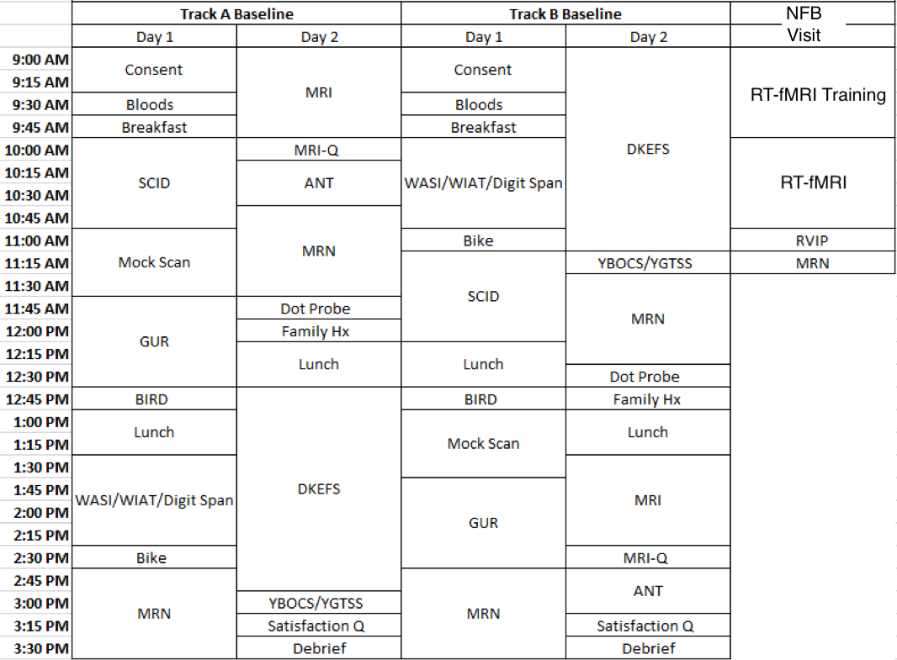

* **Consent Forms:** Consent, Demographics questionnaire, MRI screener, Contact Information
* **Bloods:** Weight/Height, Vital Signs, Hip/Waist Measurement, Medications/Medical Conditions, Grip Strength, Urine Drug Test, Blood Draw, Color Vision Test
* **MRN:** See page 27-28.

**Neurofeedback 1-Day Baseline Visit Order of Procedures**

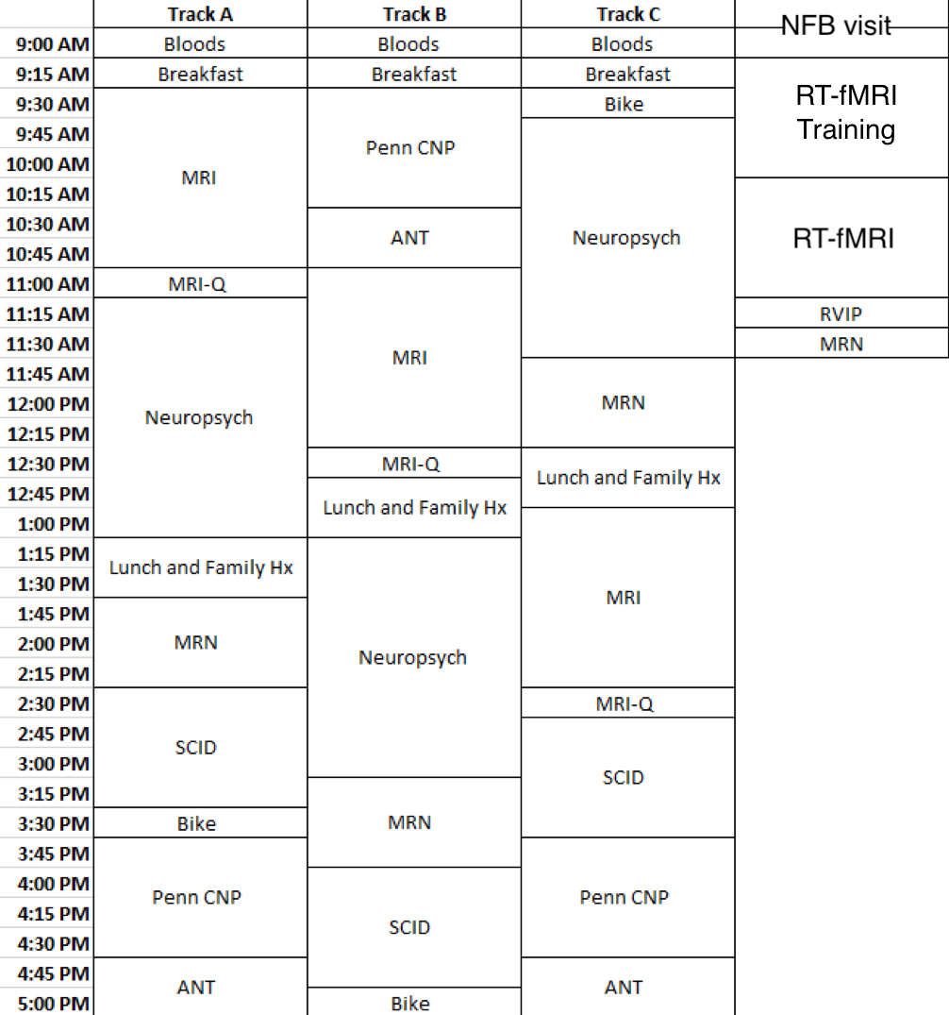

* **Consent Forms:** Consent, Demographics questionnaire, MRI screener, Contact Information
* **Bloods:** Weight/Height, Vital Signs, Hip/Waist Measurement, Medications/Medical Conditions, Grip Strength, Urine Drug Test, Blood Draw, Color Vision Test
* **MRN:** See page 27-28.

**MoCA**

**Assessment Used:** Montreal Cognitive Assessment (MoCA)

References: Nasreddine, Z.S., Phillips, N.A., Bedirian, V., Charbonneau, S., Whitehead, V., Collin, I., Cummings, J.L., & Chertkow, H. (2005). The Montreal cognitive assessment, MoCA: a brief screening tool for mild cognitive impairment. *Journal of the American Geriatric Society, (4),* 53, 695-699.

**Administration:** Prior to testing, participants were asked to turn off their cell phones to limit any potential distractions or interruptions. White noise machines were turned on outside of the testing room to limit any background noise coming from other parts of the testing center and ensure privacy. Participants were seated directly across from the examiner and all testing materials were hidden from participants’ view when not in use.

The participant was given the following introduction:

“*Today you will complete a short test that involves some things like drawing, remembering words, and answering questions. This will take just a few minutes.*

*Do you have any questions?*”

MoCA was then administered and scored according to the official administration and scoring guidelines. For more information see [www.mocatest.org](http://www.mocatest.org/)

**Actigraphy**

**Instruments used:** Philips Respironics Actiwatch 2

References: Gironda, R. J., Lloyd, J., Clark, M. E., & Walker, R. L. (2007). Preliminary evaluation of reliability and criterion validity of actiwatch-score. J Rehabil Res Dev, 44(2), 223-30.

**Administration:** The units were given to participants on the morning of the first visit. This occurred either at the consent visit or the base line visit, depending on availability of actigraphy watches and participant willingness. They were then asked to wear it on their non-dominant wrist until they return for their next visit. Actigraphy data was obtained for a minimum of 24 hours and up to 1 week, depending on how far apart the participant’s two visits were. Participants were asked to wear the actigraphy unit continuously (unit is waterproof) and asked to press the event marker button right before they are about to go to sleep.

**Demos**

**Assessments Used:** Demographics Form

**Administration:** Participants were given the demographics form and asked to fill in their age, date of birth, sex, ethnicity, race, and native language at their baseline visit. Native language was defined as the primary language learned and spoken during childhood.

**Height, Weight, and Vital Signs**

**Administration:** The participant’s height, weight, and vital signs were taken in a medical exam room in the outpatient research department. The participant stepped onto a weighted scale and weight was recorded in pounds (and converted into kilograms thereafter). Blood pressure was taken using a digital sphygmomanometer (American Diagnostic Corporation e-sphyg) with a research assistant listening with a stethoscope simultaneously to ensure accuracy. A radial pulse was also recorded by the digital sphygmomanometer. Waist and hip measurements were also recorded in centimeters during this time.

**Medications & Medical Conditions**

**Administration:** All medications and supplements taken on a regular basis were recorded in a private testing room. All medications and supplements were recorded in their generic forms. A white noise machine was turned on outside of the testing room to ensure participant confidentiality. Participants were advised to compile a list of their medications and the dosages prior to coming in for their appointments in order to enhance accuracy of the self-report. Participants were also asked to self-report any illnesses or health conditions. This was cross-referenced with the primary indications on the medications form to ensure accuracy of the self-report.

**Color Vision Test**

**Assessment Used**: Ishihara’s Tests for Colour Deficiency (24 Plates Edition) 2007

Reference: Ishihara, S. The Series of Plates Designed as a Test for Colour-Deficiency. Tokyo, Japan: Kanehara Trading Inc. (1936).

**Test Administration:** The color deficiency test was administered in the NKI-RS outpatient research department medical examination room to ensure the room is lit adequately by daylight. The Ishihara’s Tests for Color Deficiency stimulus book plates were held 75cm from the subject and tiled so that the plate of the paper is at a right angle to the line of vision. The participant was asked to state (out loud) the number which is printed on the back of the plate. Responses were recorded indicating whether the subject could read the numeral(s).

**Grip Strength**

**Instrument used:** Sammons Preston Jamar Plus+ Digital Hand Dynamometer

**Administration:** Participants were asked to squeeze the dynamometer as hard as possible, three times on each hand, switching back and forth between their left and right hands. All measurements were averaged for each hand, and participants reported which hand was dominant.

**Blood Collection & Genetics Sample Collection**

**Collection:** Three vials of blood were collected in the same order at the baseline visit to perform the following analyses:

|  |  |  |
| --- | --- | --- |
| **Vial** | **Panel(s)** | **Tests** |
| Vacuette 8mL Z Serum Sep Clot Activator | Thyroid Panel 1 | TSH, Free T4 |
| Vacuette 8mL Z Serum Sep Clot Activator | SMAC | Albumin                           Glucose             Total Bili  Alk Phos                           LDH                        Total Protein BUN                                  Phosphorus            Uric Acid   Triglycerides Potassium  Globulin  Cholesterol                      SGOT (AST)                GFR  Chloride                           A/G Ratio Sodium  CO2                                   SGPT (ALT)                  Creatine |
|  | Lipid Profiles | Cholesterol LDL  CHO/HDL Ratio HDL  Triglycerides |
| Vacuette 4 ml K3E K3eDTA tube | CBC | CBC |

One additional vial containing genetics samples was also collected. Immediately after collection, the genetics samples were packaged and sent to the RUCDR- Nelson Labs to be processed and made available through the NIMH Genetics Repository.

**Urine Toxicology**

**Test used:** CLIAwaived, Inc Rapid Drug Test Cup (CLIA-14-RDTC)

**Administration:** Urine was typically collected at the beginning of the day and tested for the presence of amphetamine, barbiturates, benzodiazepines, buprenorphine, cocaine, ecstasy, methadone, methamphetamine, marijuana, opiates, oxycodone, phencyclidine, propoxyphene, tricyclic antidepressants. Test lids were read approximately 5 minutes after activation.

**Urine Pregnancy Test**

**Test used:** Sure-Vue Urine hCG Strips (Fischer HealthCare)

**Administration:** All female participants were offered a pregnancy test prior to their MRI scan.

The test strips were then read after 3-4 minutes and a positive or negative result was determined and recorded. A positive test was a contraindication for the MRI.

**PENN CNP**

**Assessment Used:** University of Pennsylvania Computerized Neuropsychological Testing

References: Gur, R.C., et al. (2009). A cognitive neuroscience-based computerized battery for efficient measurement of individual differences: Standardization and initial construct validation. Journal of Neuroscience Methods, 187(2010), 254-262.

**Task Administration:** The following instruction was provided to the participant:

*“We will now do some memory and puzzle-like games on the computer. Some are easy and some are more difficult. Don’t worry if you make mistakes- everyone does. Try your hardest, work accurately and quickly. Some questions may take more time than others, and that’s OK. Just do your best for each one. I will let you know when you can take a break, if you want one. Do you have any questions?”*

All participants were given noise-cancelling headphones to wear during testing to prevent background noises from distracting them or interfering with the task.

The PENN CNP Battery was administered in the following order:

* Motor Praxis Test
* Emotional Recognition
* Penn Continuous Performance Test

OPTIONAL BREAK

* Penn Face Memory
* Penn Word Memory for Children
* Short Letter N-Back

OPTIONAL BREAK

* Penn Conditional Exclusion Test
* Measured Emotion Differentiation
* Short Finger Tapping (SKIPPED)

OPTIONAL BREAK

* Short Visual Object Learning Test
* Penn Verbal Reasoning

Throughout testing, participants were actively monitored by examiners. Extra assistance was provided as needed by providing verbatim instructions clearly as participants moved through the practice rounds. Extra assistance was only provided during the practice rounds and never during the tests themselves.  Coaching or assistance was never provided during Penn Conditional Exclusion Task.

**BIRD**

**Assessments used:** The Behavioral Indicator of Resiliency to Distress

Reference: Lejuez CW, Daughters SB, Danielson CW, Ruggiero K. The Behavioral Indicator of Resiliency to Distress (BIRD) 2006 Unpublished manual.

**Administration:** Participants were given the following instruction:

*“You will see ten numbered boxes (1-10) on the computer screen, as well as an image of a bird in a cage. A green dot will appear in one of the numbered boxes. Your job is to use the computer mouse to click on the numbered box where the green dot appears, before the green dot jumps to another number. Each time you manage to do that you get a point.*

*The first level will last 3 minutes. The better you do, the faster the green dot will jump.*

*The second level will last 4 minutes. It is more difficult than the first level.*

*The third and final level will last up to 5 minutes. During this level, you will always have an escape option. That is, you can end the game by clicking the “Quit Game” button on the computer screen at any time.”*

All participants were given noise-cancelling headphones to wear during testing. Subjects heard a pleasant sound and were awarded points each time they succeeded in the clicking the correct box. However, an unpleasant sound is played whenever the subjects did not click the box in time. Subjects were able to click a button to abort the game during the final portion of the test.

**Hollingshead SES**

**Assessment Used:** Hollingshead Four-Factor Index of Socioeconomic Status (SES)

Reference: Hollingshead, A. A. (1975). Four-factor index of social status. Unpublished manuscript, Yale University, New Haven, CT.

**Test Administration:** The Hollingshead SES was completed in a private testing room and a white noise machine was turned on outside of the testing room to ensure participant confidentiality. Participants were asked their highest level of education, highest grade completed, and highest level of occupation for themselves, their spouse , their mother, and their father (if known/applicable). Answers were recorded by the research assistant onto a paper version of the Hollingshead SES and were scored thereafter.

**SCID & Consensus Diagnosis**

**Assessment Used:** Structured Clinical Interview for DSM-IV-TR Axis I Disorders (Nonpatient Edition)

Reference: First, M., B., Spitzer, R. L., Gibbon, M., and Williams, J.B.W.: Structured Clinical Interview for DSM-IV-TR Axis I Disorders, Research Version, Non-patient edition (SCID-I/NP, 1/2010 revision). New York: Biometrics Research, New York State Psychiatric Institute, November 2002.

Administration: SCID was completed in accordance with the official interviewing and scoring guidelines outlined in the training materials published by the APA. Consensus diagnoses were given only in the event that the examiner’s overall impression of a diagnosis differed from the diagnoses obtained through SCID scoring.

**ACDS**

**Assessment Used:** Adult ADHD Clinical Diagnostic Scale (ACDS)

Reference: Kessler, R. C., Green, J. G., Adler, L. A., Barkley, R. A., Chatterji, S., Faraone, S. V., . . . Van Brunt, D. L. (2010). Structure and diagnosis of adult attention-deficit/hyperactivity disorder: Analysis of expanded symptom criteria from the adult ADHD clinical diagnostic scale. Archives of General Psychiatry, 67(11), 1168-78.

**Test Administration:** The ACDS was completed in a private testing room and a white noise machine was turned on outside of the testing room to ensure participant confidentiality. The participant was asked to focus on the “period of time before they became a teenager, roughly the time corresponding to elementary or primary school.” The research assistant was then asked questions A1 – A21 aloud and responses were recorded on paper according to the ACDS scoring guidelines. The participant was then asked to “think about only the past twelve months, that is, since [month, year].” The research assistant was then asked questions B1 – B21 aloud and responses were recorded on paper according to the ACDS scoring guidelines.

**Mock Scan**

**Instrument used:** 0T Mock Scanner, MoTrack Head Motion Tracking System, Brain Logics MR Digital Projection System, 32 Channel head coil, noise-cancelling headphones.

**Administration:** Participants were informed that they would be completing a mock scan, where they would be entering the MRI tunnel and looking at different movies and images on a screen without the machine taking any pictures of their brain. Staff explained that unlike the real scan, the mock scan would be performed in a different room and would not require them to wear ear plugs. Participants were assured that they would be able to speak with staff at any point if they became uncomfortable or claustrophobic during the mock scans.

After this orientation, participants were set up with the MoTrack device and headphones. After securing the coil, helmet, and knee cushion, participants were brought into the tunnel.

Participants were then read the following instruction to orient themselves to the task:

“*Now we are going to practice lying still inside the scanner. You will see an X. Your job is to keep that X in the green circle by staying as still as possible. You will see that if you move your head, the X will move. If you move outside of the green circle, a noise will remind you to stay still. Please do so, and I will put the X back in the middle of the green circle for you. Don’t try to put it back yourself, because you would be moving a lot then! So sometimes you’ll see the X jumping. That’s me putting it back in the green circle for you. Do you have any questions?*”

The participant then completed one practice trial and three mock scans, during which they were read the following instructions:

|  |  |
| --- | --- |
| **Computer Trial** | **Script** |
| Practice | “Try moving your head so you can hear the beep. Good job! Now try keeping your head still but moving your arms and legs. As you can see, when you move other parts of your body, your head will still move sometimes. That’s why you need to keep your entire body still when you hear the noises. Do you have any questions?” |
| Target | “Now you are going to practice lying still while I play some sounds in the background. This first scan is three minutes, so just make sure you tryy and keep that X in the green circle by staying as still as you can.” |
| Cartoon | “Now you are going to watch a cartoon just to give you more practice lying still. When you watch the cartoon this time, you will see that whenever you move, the cartoon stops. Just like the last san when you had to stay still to keep the X in the green circle, now you have to stay still to see the whole cartoon. Remember to stay still so that the cartoon finishes quickly! Any questions? Are you ready?” |
| 6 Minute Rest | “Now you are going to practice one of the scans that you are going to do in the real scanner so that you get really good at it. We are going to ask you to lie as still as you can for 6 minutes while you keep your eyes open and look at a white cross. You will see ‘Relax’ on the screen and after about 20 seconds, it will switch to the cross” |

**MRI & MRI Questionnaire**

**Instruments:** 3T Siemen’s MRI scanner, Linux computer, Lumina Box, AcqKnowledge 4.2 BIOPAC program, “Memory of Trees” CD by Enya, Biopac Systems Disposable RT electrodes, Biopac Systems Respiratory Efforts Transducer, Brain Logics MR Digital Projection System, 32 Channel head coil, noise-cancelling headphones, disposable earplugs

**Task Administration:**

Prior to scanning, participants were screened for contraindications including specific medical conditions and metal artifacts in or on their person to ensure safety. After the participants were cleared for the MRI, the research assistant provided instructions for each scan (included in the list below) upon walking participants to the scanner. Participants’ were asked to remove everything from their pockets as well as bags, jewelry, belts, hearing aids, dentures, hair clips, or piercings. Participants’ belongings were stored and locked in a secure room. If applicable, the time of participants’ caffeine intake prior to scanning was recorded.

To prepare participants for scanning, the research assistants provided practice instructions and related stimuli for each scan on a Linux computer. The participants were then taken into the scanning room by the MRI technician(s) and were fitted with a respiration belt around their waist, a pulse transducer, and electrodes on their fingers to record their respiration rate, pulse rate, and galvanic skin response (GSR), respectively. Additionally, participants were provided with ear plugs and headphones to reduce noise in the scanner. Participants were given an emergency button to alert the research assistant and technician(s) if they felt that they could no longer continue scanning. For specific scans, participants were also given a pad with four buttons to press in response to applicable stimuli.

Upon entering the MRI tunnel, the research assistant ensured that the participants were prepared for scanning via microphone, and checked that the microphone was at an appropriate volume for the participants. On the computer, the research assistant completed a calibration period in which they reviewed the respiration, pulse, and GSR waveforms through the AcqKnowledge 4.2 computer program to verify that the signals were clear. Throughout scanning, the research assistant provided the specific length and instructions to the participants for each upcoming scan by reading an established script verbatim. BIOPAC data were saved for each applicable scan by the research assistant from the AcqKnowledge program. Participants were reminded to remain as still as possible throughout scanning and were able to speak to the research assistant via microphone in between each scan.

The following table includes the names, lengths, and instructions for each scan that participants completed. During scans with music, a “Memory of Trees” CD by Enya was played.

|  |  |  |  |  |
| --- | --- | --- | --- | --- |
| **Name of Scan** | **BIOPAC Data** | **Music** | **Stimuli** | **Instructions** |
| BIOPAC Calibration | Waveforms reviewed, data not saved | Off | None | Participants were asked to inhale, hold their breath for 1-2 seconds, and exhale for a short period of time. MRI technicians adjusted participants’ sensors as necessary. |
| Localizer (1 minute) | Off | On | None | Participants were informed that the scan would be 1 minute long and would include music. Participants were instructed to keep their eyes open or closed, whichever was more comfortable. |
| REST_645 | On | Off | Fixation | Participants were informed that the scan would be 10 minutes long and that they should keep their eyes fixated on the cross. |
| MPRAGE | Off | On | Fixation | Participants were informed that the scan would be 4 minutes long and would include music. They were told that they could keep their eyes open or closed. |
| REST_1400 | On | Off | Fixation | Participants were informed that the scan would be 10 minutes long and that they should keep their eyes fixated on the cross. |
| REST_CAP | On | Off | Fixation | Participants were informed that the scan would be 5 minutes long and that they should keep their eyes fixated on the cross. |
| CHECKER_645 | On | Off | Checkerboard | Participants were told to keep their eyes focused on a red dot on the screen and to press any button each time they saw the checkerboard appear behind the dot. They were informed that the scan was 2 minutes long. |
| CHECKER_1400 | On | Off | Checkerboard | Participants were told to once again keep their eyes focused on a red dot on the screen and to press any button each time they saw the checkerboard appear behind the dot. They were informed that the scan was 2 minutes long. |
| BREATH_HOLD_1400 | On | Off | Breath Hold | Participants were instructed to follow the prompts on the screen for the duration of the 4 minute scan. They were reminded that they should breathe normally whenever they saw the word “rest” and that they should keep as still as possible when taking deep breaths. They were advised not to worry if they could not hold their breathe for the full interval indicated by the prompts, but to try their best. |
| PCASL_REST | On | Off | Fixation | Participants were informed that the scan would be 5 minutes long and that they should keep their eyes fixated on the cross. |
| DIFF_137 | On | On | Fixation | Participants were informed that the scan would be 6 minutes long and include music. They were told that they would feel the table shake and vibrate, but that this was normal. They were also told to keep their eyes open or closed, whichever they preferred. |
| HCP_SPACE & FLAIR | Off | On | Fixation | Participants were informed that the final scan would be seven minutes long. They were reminded that they could keep their eyes open or closed. |

Immediately after the scan, participants completed the **MRI-Questionnaire (MRI-Q),** a short survey detailing their experiences and thoughts during the MRI scan.

**6 minute bike**

**Bike Used:** Precor (RBK 10: HCOM 815)

**Test administration:**

1. A resistance level and estimated wattage at 70 RPM were determined based on participants’ age and gender.

|  |  |  |  |
| --- | --- | --- | --- |
|  | Age | Resistance | Estimated Wattage at 70 RPM |
| Males | **< 35** | **8** | **133.16** |
|  | **35-55** | **7** | **121.89** |
|  | **>55** | **6** | **110.62** |
| Females | **<35** | **7** | **121.89** |
|  | **35-55** | **6** | **110.62** |
|  | **>55** | **5** | **99.35** |

1. A pulse oximeter was applied to the participant’s finger to monitor heart rate throughout testing. Participants were also instructed to grip the heart rate monitor on the bike’s handles throughout testing as a secondary way of measuring their pulse rate.
2. Participant’s initial heart rate was recorded from the bike and pulse oximeter.
3. Participants were instructed to begin pedaling at 70 rpm and the appropriate resistance level was set.
4. Participants were asked to cycle for 6 minutes, during which they were monitored to ensure that their speed was between 68-72 rpms. If the participant was unable to complete the full 6-minute interval, failure time was recorded.
5. Final heart rate was recorded from the bike and pulse oximeter at the end of the 6-minute interval, or at time of failure.

**Neuropsych Battery: Overview**

**Assessments used:** Delis Kaplan Executive Function System (DKEFS; Verbal Fluency, Trails, Design Fluency, Color-Word Interference, Tower), Rey Auditory Verbal Learning Test (RAVLT), Digit Span (Forward and Backward), Grooved Pegboard, Wechsler Abbreviated Scale of Intelligence II (WASI-II), Wechsler Individual Achievement Test (WIAT-IIA).

**Test administration:** Prior to testing, participants were asked to turn off their cell phones to limit any potential distractions or interruptions. Participants were encouraged to take short breaks as needed in between assessments to prevent interruptions during individual parts of the battery. White noise machines were turned on outside of the testing room to limit any background noise coming from other parts of the testing center and ensure privacy. Participants were seated directly across from the examiner and all testing materials were hidden from participants’ view when not in use.

Each participant was read the following introduction to testing:

*We’ll be doing a lot of things today, like remembering words and numbers, answering questions, connecting circles on a page. Some of the things may be really easy for you, but some of them may be hard. Most people do not answer every question correctly or finish every item, but please try your best. Do you have any questions?*

The order of test/subtest administration was as follows:

1. DKEFS Verbal Fluency
2. RAVLT (Immediate Recall)
3. DKEFS Trails
4. Digit Span (Forward & Backward)
5. DKEFS Design Fluency
6. DKEFS Color-Word Interference
7. DKEFS Tower
8. Grooved Pegboard
9. RAVLT (Delayed Recall)
10. WASI
11. WIAT

Each individual assessment was administered and scored according to the official administration and scoring guidelines for that test or subtest. These materials were provided by the administration manuals published for the Delis Kaplan Executive Function System, Rey Auditory Verbal Learning Test, Digit Span, Grooved Pegboard, Wechsler Abbreviated Scale of Intelligence II, and Wechsler Individual Achievement Test. All assessments were double scored by research staff prior to entry.

Neuropsych batteries were typically completed first thing in the morning or directly after lunch. Assessments were not typically administered directly before or after computerized cognitive tests (ANT, Penn CNP, RVIP). If this did occur due to scheduling conflicts, participants were provided with a 15-minute break in between the neuropsych battery and computerized testing.

*The neuropsych battery was modified at the time of procedure change from two day to one day baseline testing. The full DKEFS battery with all subtest were administered in the two day protocol, however the one day protocol retained the DKEFS subtests listed above.

**MRN:** A set of self assessment questionnaires completed through the Mind Research Network (MRN) online interface.

**Administration:** Participants were seated at a computer and given the following instruction:

“*You’re going to be answering a lot of questionnaires about several different topics. You’ll notice the questionnaires are a bit repetitive, they are supposed to be that way to maintain validity for all responses. If you have any questions, feel free to ask.*”

The following assessments were completed at home, prior to the baseline visit:

Demos supplement

Zip Code

NEO-FFI-3

EHQ

CAARS-S:S

CFQ

FTND

EDEQ

IPAQ

ICUY

Med HX-Adult

UPPS-P

CASI-A

IRI

Social Network (22+)

DOSPERT

TFEQ

PDI-21

NIDA

CHRLS

PSQI

ATQ

BISQ

The following assessments were completed on-site:

|  |  |
| --- | --- |
| Baseline Visit | Visit 2 |
| BDI-II | AIM |
| STAI | ERQ |
| UCLA Youth | PANAS-S |
| TSC-40 | QME |
| Sex-role Identity Scale | RRS |
| Sexual Orientation Scale | PTQ |
| PhenX Sexual History | PSWQ |
| ASR-Adaptive Functioning Scales | SIPI |
| ASR |  |
| YRBS-HS (21 only)  YBOCS*  YGTSS* |  |

*completed in-person with research staff

A description of each assessment listed above can be found here:<http://fcon_1000.projects.nitrc.org/indi/enhanced/assessments/master_list.html>

All responses were reviewed by research staff to check for completion.

**ANT**

**Assessment Used:** Attention Network Task

References: Fan, J., McCandliss, B. D., Sommer, T., Raz, A., & Posner, M. I. (2002). Testing the efficiency and independence of attentional networks. Journal of Cognitive Neuroscience, 14(3), 340-7. doi:10.1162/089892902317361886

**Administration Test:** Participants were given the following instruction:

*“This is an experiment investigating attention. You will be shown an arrow on the screen pointing either to the left or to the right. Your task is to press the left arrow key on the keyboard when the middle arrow points left and the right arrow when the middle arrow points right. Use your index finger for the left arrow and your right index finger for the right arrow”*

*“Sometimes the middle arrow will be surrounded by two arrows to the left and right. Your task is to respond only to the direction of the central arrow. Please make your response as quickly and accurately as possible.”*

*“There will be a cross in the center of the screen and the arrows will appear either above or below the cross. You should try to look at the cross throughout the experiment. On some trials there will be asterisks indicating when or where the arrow will occur. You may look at these asterisks when they appear”*

*“There is one practice session, which takes 2 minutes. Then there are 3 test sessions; each are 5 minutes long. You can take a short break between the sessions if you’d like. If you have any questions, please ask the experimenter. If you understand these instructions, you may start the practice session.”*

All participants were given noise-cancelling headphones to wear during testing to prevent background noises from distracting them or interfering with the task. If participants began using one hand to select the arrow keys, they were reminded to use their right and left index fingers for the right and left arrow keys, respectively. All testing was performed in a quiet environment with active monitoring by an examiner.

**Calculated Age**

**Administration:** Participant’s exact age at the time of the MRI scan was calculated based on the date of the appointment and their date of birth. All calculations were made using 12-month years and 30-day months.

**Family History Questionnaires**

**Assessment Used:** Family History Questionnaire, custom created by NKI-RS investigators

**Test Administration:** The family history questionnaires were completed in a private testing room and a white noise machine was turned on outside of the testing room to ensure participant confidentiality. Participant was asked to identify their living or deceased biological family members (i.e., Mom, Dad, Siblings, Children). Participant then recorded family history questionnaires on paper assessments for each family member and returned completed questionnaires to research assistant when completed. These data are not available through the Data Usage Agreement due to privacy concerns.

**Dot Probe**

References: Abend, R., Pine, D.S., Bar-Haim, Y. (2014). The TAU-NIMH Attention Bias Measurement Toolbox. Retrieved from <http://people.socsci.tau.ac.il/mu/anxietytrauma/research/>.

MacLeod, C., Mathews, A., & Tata, P. (1986). Attentional bias in emotional disorders. Journal of Abnormal Psychology, 95, 15-20. doi:10.1037/0021-843X.95.1.15

**Administration:** In this task, a pair of faces, one threat-related and one either neutral or happy, were shown briefly side-by-side. A small probe replaced one of the faces immediately following offset. Participants were then required to respond as quickly as possible by pressing keys on a keyboard to indicate which face was replaced by a dot without compromising accuracy. The face stimuli were usually photographs of 16 different individuals (8 male, 8 female) taken from the NimStim set.

Instructions were read verbatim to the participant directly from the Dot Probe task on the computer screen. All participants were given noise-cancelling headphones to wear during testing to prevent background noises from distracting them or interfering with the task.

**Y-BOCS & CY-BOCS**

**Assessment Used:** Yale-Brown Obsessive-Compulsive Scale & Child Yale-Brown Obsessive-Compulsive Scale

Reference: Goodman, W.K., et al. (1989). The Yale-Brown Obsessive-Compulsive Scale. I. Developmental use and reliability. Archives of General Psychiatry, 46(11), 1006-11.

**Test Administration:** The CY-BOCS and Y-BOCS rating scales is 10-item semi-structured clinician –rating instruments that assessed the severity and type of OCD symptoms in children and adolescents (ages 6-14) and adolescents and adults (ages 14 and up). Severity of compulsions and obsessions were rated on a 5-point scale. The scale asked individuals to respond based on symptoms experiences only in the past week. Ratings were primarily based on the participant’s report, however the final ratings are based on the clinical judgment of the interviewer. Interviews were conducted in a private testing room with a white noise machine outside to ensure patient confidentiality.

**YGTSS**

**Assessment Used:** Yale Global Tic Severity Scale

Reference: Leckman J.F., Riddle M.A., Hardin M.T., Ort S.L., Swartz K.L., Stevenson J., et al. The Yale Global Tic Severity Scale: Initial testing of a clinician-rated scale of tic severity. Journal of the American Academy of Child and Adolescent Psychiatry. 1989;28:566–573.

**Test Administration:** The YGTSS rating scale is a 10-item semi-structured clinician-rating instrument that provides an evaluation of the number, frequency, intensity, complexity, and interference of motor and phonic symptoms. The items pertaining to the tic ratings were scored on two subscales: motor tics and phonic tics. Behaviors were rated on a 6-point scale. The scale asked individuals to respond based on symptoms experiences only in the past week. Interviews were conducted in a private testing room with a white noise machine outside to ensure patient confidentiality.

**Real Time fMRI (RT-fMRI) Training**

Training was completed immediately prior to RT-fMRI. Research staff administered three computerized tasks to participants, outside of the MRI scanner:

1) Moral Dilemma:

Participants were then set up with a pair of headphones and given the following instruction:

“*A series of short stories will be read to you while you view corresponding illustrations. Some of these may be a little emotionally distressing. Please pay close attention to the stories and illustrations – you will be asked questions about them during the MRI scan. After a story is completed, press the space bar to advance to the next one. Also, please let me know as soon as possible if the volume needs to be readjusted.*”

Participants then moved through the stories at their own pace with research staff present in the room.

2) MSIT Training:

Participants were given the following instruction:

“*Every few seconds, a set of three numbers (1, 2, 3, or 0) will appear in the center of the screen. One number will always be different from the other two. Press the button corresponding the identity – not the position – of the differing number. Please use your index finger for ‘1’ on the ‘H’ key, your middle finger for ‘2’ on the ‘J’ key, and your ring finger for ‘3’ on the ‘K’ key. Answer as accurately and as quickly as possible. This is a practice round so you will get corrective feedback throughout the task.*"

Participant then completed the task with research staff monitoring to ensure that they were comfortable with the accurately completing it.

3) NFB Training:

Participants were given a sheet of instructions detailing the procedures for feedback scans. Research staff ensured that participants read and understood the instructions before they moved on to scanning.

**Real Time fMRI session (includes Resting State, Peer, RT-fMRI Neurofeedback, MSIT, Moral Dilemma)**

**Instruments:** 3T Siemen’s MRI scanner, Linux computer, Lumina Box, AcqKnowledge 4.2 BIOPAC program, Biopac Systems Disposable RT electrodes, Biopac Systems Respiratory Efforts Transducer, Brain Logics MR Digital Projection System, 32 Channel head coil, noise-cancelling headphones, disposable earplugs

**Task Administration:**

Prior to scanning, participants were screened for contraindications including specific medical conditions and metal artifacts in or on their person to ensure safety. After the participants were cleared for the MRI, the research assistant provided instructions for each scan (included in the list below) upon walking participants to the scanner. Participants’ were asked to remove everything from their pockets as well as bags, jewelry, belts, hearing aids, dentures, hair clips, or piercings. Participants’ belongings were stored and locked in a secure room. If applicable, the time of participants’ caffeine intake prior to scanning was recorded.

Following RT-fMRI training, participants were asked if they had any questions regarding the instructions they had read or the tasks they had completed. Any questions were addressed, and the following instruction was read:

*“We will be attaching some monitors to measure your breath, pulse, and sweat glands. In a moment, we’re going to set everything up. We will record two of the measures from your feet and one from your chest or abdomen. Once everything is set up, we will need to briefly test the equipment to make sure we are getting a good signal. What I will ask you to do is to take a deep breath in and hold it for a second or two, and then exhale. I’d like you to repeat that pattern for a short period of time. I will tell you when to start this pattern of deep breathing.”*

The participants were then taken into the scanning room by the MRI technician(s) and were fitted with a respiration belt around their waist, a pulse transducer, and electrodes on their fingers to record their respiration rate, pulse rate, and galvanic skin response (GSR), respectively. Additionally, participants were provided with ear plugs and headphones to reduce noise in the scanner. Participants were given an emergency button to alert the research assistant and technician(s) if they felt that they could no longer continue scanning. For specific scans, participants were also given a pad with four buttons to press in response to applicable stimuli.

Upon entering the MRI tunnel, the research assistant ensured that the participants were prepared for scanning via microphone, and checked that the microphone was at an appropriate volume for the participants. On the computer, the research assistant completed a calibration period in which they reviewed the respiration, pulse, and GSR waveforms through the AcqKnowledge 4.2 computer program to verify that the signals were clear.

The participant was then shown an eye chart on the projector in the MRI tunnel, and given the following instruction:

*“Please adjust the mirror so that you can see the entire eye chart without moving your head. You may notice a double reflection of the chart. You can fix this reflection by sliding the mirror slightly towards your chin. Have you adjusted the mirror? Can you see the entire eye chart without moving your head? Please read the lowest visible line from the eye chart.”*

The participant was then asked to reposition until they were able to read the lowest line of the eye chart. They were then read the following instruction:

*“We will now begin the scanning procedure, please remain as still as possible during the entirety of the scan, even when the scanner is not actively acquiring images. I will check in with you between scans to provide further instructions and to make sure you are OK. If you become distressed during the scan you may use the squeeze bulb to stop the scan.”*

Throughout scanning, the research assistant provided the specific length and instructions to the participants for each upcoming scan by reading an established script verbatim. BIOPAC data were saved for each applicable scan by the research assistant from the Acqknowledge program. Participants were reminded to remain as still as possible throughout scanning and were able to speak to the research assistant via microphone in between each scan. The following table includes the names, lengths, and instructions for each scan that participants completed.

|  |  |  |
| --- | --- | --- |
| **Scan** | **Stimulus** | **Script** |
| Localizer | None | We will begin with a short one minute second scan. |
| T1 | None | Next is a five minute anatomical scan. You may have your eyes open or closed during this scan. Please remain as still as possible. There will be a brief delay while we prepare for the next part of the experiment. |
| Phase Map | None | Next will be a minute long scan, you may have your eyes open or closed during this scan. Please continue to stay as still as possible. There will be a brief delay while we prepare for the next part of the experiment. |
| Mask | None | Next is a short 15 second scan |
| Resting State | Fixation | Next is a resting state scan. Please lie quietly with your eyes open and direct your gaze towards the cross in the middle of the screen. During this scan let your mind wander freely. Do not perform any sort of mental calculation, memory recall, or other mental tasks. If you notice yourself focusing on a particular stream of thoughts, let your mind wander away. Please stay awake and remain as still as possible. This scan will last 6 minutes. (BIOPAC recorded) |
| Peer | Peer | Next is the ``follow the dot'' task. A dot will appear at random locations on the screen. Direct your gaze on the dot for the entire time that it is visible on the screen. Move your eyes only and not your head. This scan will last about 2 minutes. |
| Neurofeedback (RT-fMRI) | Feedback | Next is the feedback task. During this scan please direct your gaze to the instruction at the bottom-middle of the brain-o-meter. Depending on the instruction, modulate your thoughts to move the needle toward either the ``focused'' or ``wandering'' label. Remember that these labels will periodically swap during the scan. Also remember that you will be periodically asked to push a button. Please do not count out loud or otherwise move your mouth during the scan. This scan will last 12 minutes, please stay as still as possible. (BIOPAC recorded) |
| MSIT | MSIT | Next is the number task. When the scan starts, a white dot will appear on the screen for 30 seconds before the task begins. Once the task starts, please remember to report the value of the number that does not belong in the set. The sets of numbers will change about every two seconds. Please answer as quickly as possible, but since getting the correct answer is important, do not sacrifice accuracy for speed. This scan will last about 7 minutes. (BIOPAC recorded) |
| Set Volume | Set Volume | In the next scan you will be asked to answer some questions. Before we begin, we are going to set the volume for you to ensure that you can hear the questions while the scanner is going and you are comfortable. I am going to play a recording and run the scanner in the background. You may adjust the volume by pressing “1” to increase and “2” to decrease. |
| Moral Dilemma | Moral Dilemma | In this scan you will see the images associated with the stories and situations you watched earlier. Each picture will be accompanied by a yes/no question. Please indicate your answer to the question by using the keypad provided. Press 1 for YES and 2 for NO. The scenarios will be changing quickly so do not spend a long time thinking about your responses. This scan will last about 4 minutes. Do you have any questions? (BIOPAC recorded) |

**RVIP**

**Assessment Used:** Rapid Visual Information Processing (RVIP)

References: Sahakian, B.J. & Owen, A.M. (1992). Computerized assessment in neuropsychiatry using CANTAB: discussion paper. Journal of the Royal Society of Medicine, 85, 399-402.

Stanislaw, H. & Todorov, N. (1999). Calculation of signal detection theory measures. Behavior Research Methods: Instruments & Computers, 31: 137-149.

Wesnes K, Warburton DM (1984). Effects of scopolamine and nicotine on human rapid information processing performance. Psychopharmacology 82: 147–150.

**Test Administration:** Participants were given the following instruction:

*“A string of numbers will be presented in a box in the center of the screen one at a time. The numbers will be moving pretty quickly. Press the space bar if you see the number sequences (2-4-6), (3-5-7), or (4-6-8) in a row. This is a practice round so you will initially be prompted when to respond to the target sequence. Eventually those cues will go away, but you will also receive feedback “hit” or “false alarm” if you respond accurately throughout the practice. Please answer as accurately and as quickly as possible.”*

The practice round was then administered. The participant was actively monitored by the examiner throughout the practice round to ensure that they were able to complete the task correctly. If not, the instructions were reiterated as needed. After the practice round, the following instruction was provided:

*“Now we will do the real task. This will be the same as the practice, except you will not receive any feedback. The sequences to look for will be the same. Please answer as accurately and as quickly as possible.”*

All participants were given noise-cancelling headphones to wear during testing to prevent background noises from distracting them or interfering with the task. All testing was performed in a quiet environment with active monitoring by an examiner.